**PRACTICAL NO:-1**

1. **Create an application to print on screen the output of adding, subtracting, multiplying and dividing two numbers entered by the user in C#.**

**CODE:-**

using System;

using System.Collections.Generic;

using System.Linq;

using System.Text;

using System.Threading.Tasks;

namespace pract1_console

{

class Program

{

void op(decimal a, decimal b)

{

decimal res;

int x;

Console.WriteLine(" Please enter the opearation you want to perform" +

" \n1. Addition" +

"\n 2. substraction " +

"\n 3.multiplication"

+ "\n 4. Division"

);

x = Convert.ToInt32(Console.ReadLine());

if (x < 5 && x > 0)

{

if (x == 1)

{

res = a + b;

}

else if (x == 2)

{

res = a - b;

}

else if (x == 3)

{

res = a * b;

}

else

{

res = a / b;

}

Console.WriteLine(" The result of operation is "+res);

}

}

static void Main(string[] args)

{

decimal a,b;

Program p = new Program();

while (true)

{

Console.WriteLine("please enter the first number ");

a=Convert.ToDecimal(Console.ReadLine());

Console.WriteLine("please enter the second number ");

b = Convert.ToDecimal(Console.ReadLine());

p.op(a, b);

}

}

}

}

**OUTPUT:-**

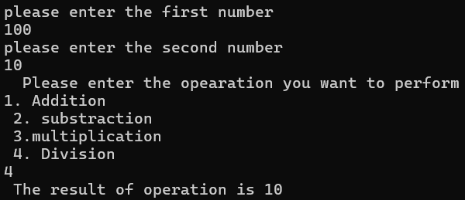

**b. Create an application to print Floyd’s triangle till n rows in C#.**

**CODE:-**

using System;

using System.Collections.Generic;

using System.Linq;

using System.Web;

using System.Web.UI;

using System.Web.UI.WebControls;

namespace practical_some_first

{

public partial class floyd : System.Web.UI.Page

{

protected void Page_Load(object sender, EventArgs e)

{ int a=1, i;

for (i=1;i<=5;i++)

{

for (int j = 1; j <= i; j++)

{

Response.Write(" "+a+" ");

a++;

}

Response.Write("<br>");

}

}

}

}

**OUTPUT:-**

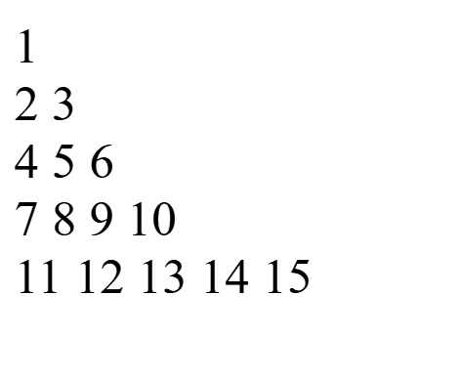

1. **Create an application to demonstrate following operations i. Generate Fibonacci series.**

using System;

using System.Collections.Generic;

using System.Linq;

using System.Text;

using System.Threading.Tasks;

namespace pract1_console

{

class Program

{

static void Main(string[] args)

{

/* decimal a,b;

Program p = new Program();

while (true)

{

Console.WriteLine("please enter the first number ");

a=Convert.ToDecimal(Console.ReadLine());

Console.WriteLine("please enter the second number ");

b = Convert.ToDecimal(Console.ReadLine());

p.op(a, b);

*/

int a=0, b=1 ,d=0;

for (int c = 1; c < 10; c++)

{

Console.WriteLine(a);

d = a + b;

a = b;

b = d;

}

Console.ReadKey(); //for holding purpose

}

}

}

**OUTPUT:-**

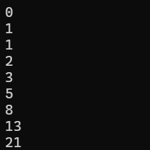

**ii. Test for prime numbers.**

**CODE:-**

using System;

using System.Collections.Generic;

using System.Linq;

using System.Text;

using System.Threading.Tasks;

namespace pract1_console

{

class Program

{

static void Main(string[] args)

{

try

{

Console.WriteLine("please enter the number ");

int a = Convert.ToInt32(Console.ReadLine());

bool c=false;

for (int i = 2; i < a; i++)

{

if (a % i == 0)

{

c = true;

}

}

if (c == true)

{

Console.WriteLine("Number is not prime number");

}

else

{

{

Console.WriteLine("Number is prime number");

}

}

Console.ReadKey();

}

catch

{

Console.WriteLine("Please insert valid number");

Console.ReadKey();

}

}

}

}

**OUTPUT:-**

